2.78: The elevators to the observation deck of the Sears Tower in Chicago move from the ground floor to the 103rd floor observation deck in about 70 s. Estimating a single floor to be about 3.5 m (11.5 ft), the average speed of the elevator is 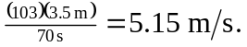 Estimating that the elevator must come to rest in the space of one floor, the acceleration is about 